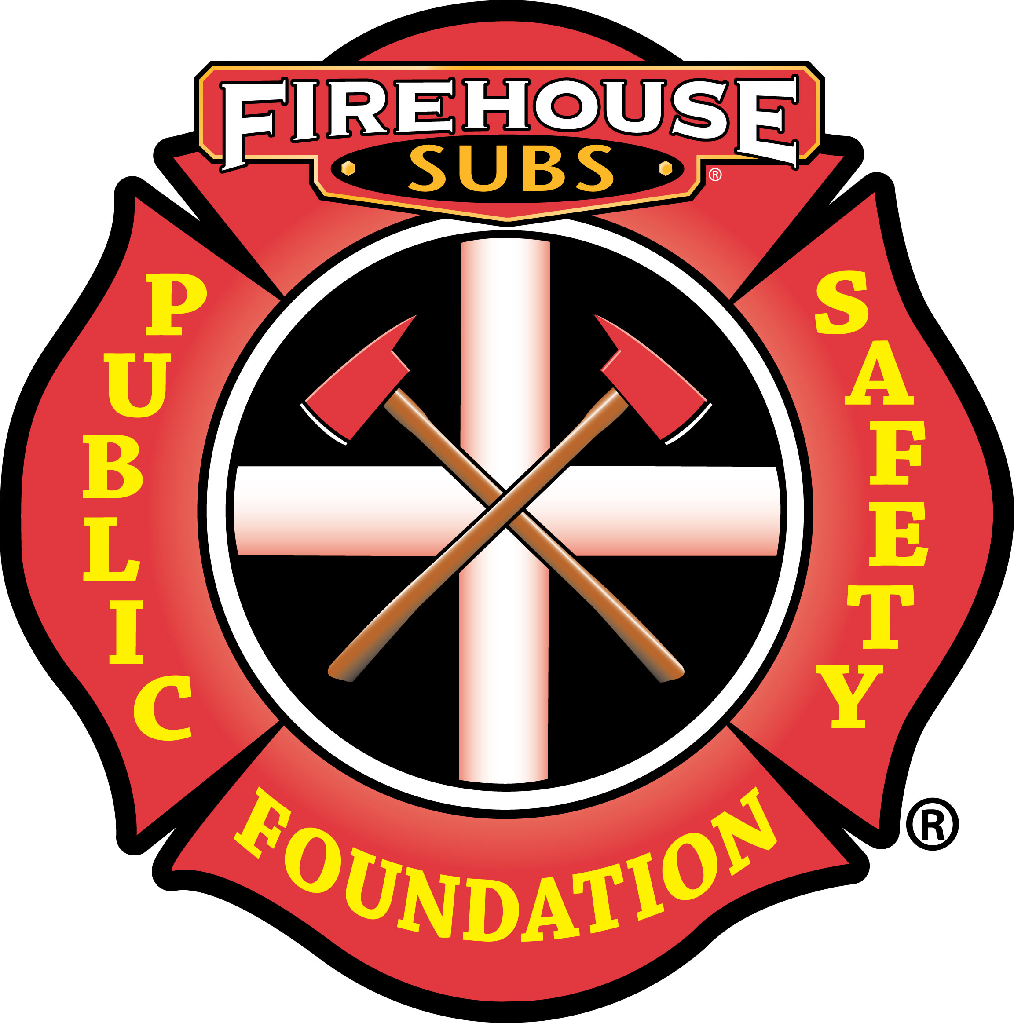

For Immediate Release

Flowes Store Volunteer Fire Department Receives Lifesaving Equipment Thanks to
Firehouse Subs Public Safety Foundation

Concord, NC – Thanks to Firehouse Subs Public Safety Foundation, Flowes Store Volunteer Fire Department is now better equipped to keep our community safe. Flowes Store Volunteer Fire Department recently received a $24,785.48 grant award from the Foundation to purchase Hurst Edraulic vehicle extrication equipment.

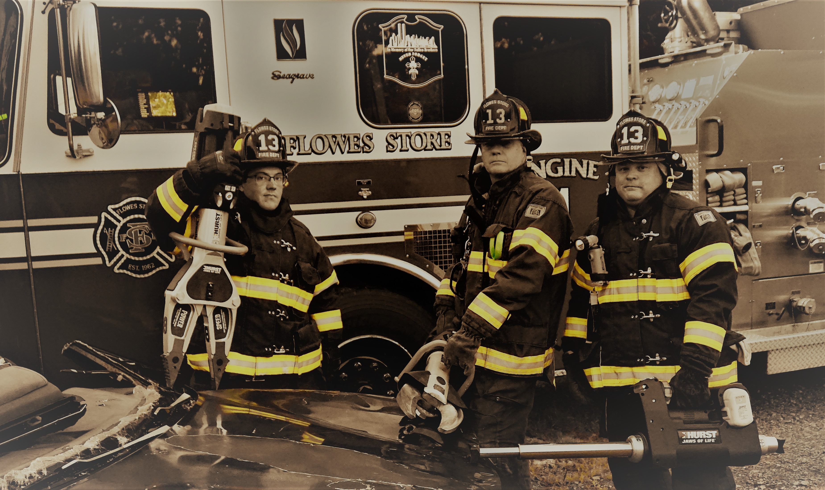
ABOUT FIREHOUSE SUBS PUBLIC SAFETY FOUNDATION
In 2005, the Firehouse Subs Founders established the 501(c)(3), non-profit Firehouse Subs Public Safety Foundation. The charity provides funding resources, lifesaving equipment, prevention education, training and disaster relief support to first responders and public safety organizations. Since inception, Firehouse Subs Public Safety Foundation has granted more than $50 million to hometown heroes in 49 states and Puerto Rico.

Firehouse Subs Public Safety Foundation is honored to be listed as a four-star nonprofit organization by Charity Navigator. Their highest designation. Grant allocations are made possible thanks to the overwhelming support of Firehouse Subs restaurants and generous donors.

Grant allocations are made possible thanks to the overwhelming support of Firehouse Subs restaurants and generous donors. More than 70% of the funds raised for the Firehouse Subs Public Safety Foundation come from the generosity of Firehouse Subs guests and the restaurant brand. Please consider supporting a Firehouse Subs restaurant near you.

