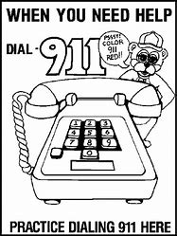

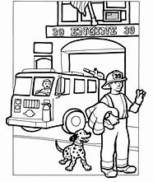

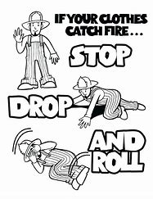

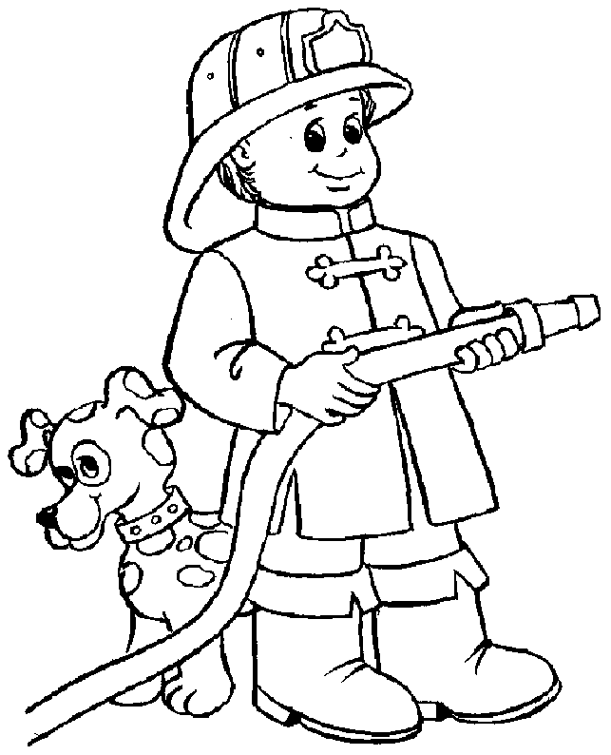

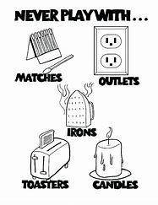

[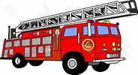](https://www.bing.com/images/search?view=detailV2&ccid=nCvQJ7ra&id=F3F8E039E343D74A86A6EB92B81E312E09DCD5C4&thid=OIP.nCvQJ7rahYfQMRnGE-Cx6gHaEB&mediaurl=https://clipground.com/images/cartoon-fire-truck-clipart-9.jpg&exph=707&expw=1300&q=free+fire+clip+art&simid=608017294122552945&selectedIndex=181)**Fire Escape Plan**

**Make a plan to get out in case of fire and know more than 1 way to get out**

**Write down your Plan**

**Draw out your plan**

[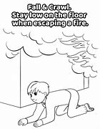](https://www.bing.com/images/search?view=detailV2&ccid=%2bnzoOMm7&id=DE50E1D3B775DD75D7AA04AE2068E68FA894B15E&thid=OIP.-nzoOMm7DFo_i0MlxngvHgAAAA&mediaurl=http://www.supercoloring.com/sites/default/files/styles/coloring_medium/public/cif/2017/12/crawl-low-under-smoke-coloring-page.png&exph=480&expw=371&q=free+fire+safety+crawling+under+smoke+pics&simid=608042750475571147&selectedIndex=29)

